Data Communications and Networking
Lab 2 – Cisco Routers

Part 1:
Installed c2691-adventerprisek9-mz.124-25d.image router image

Part 2:
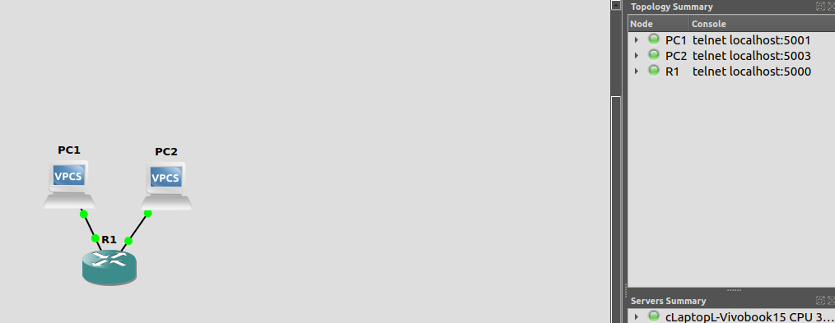
_{Topology Created}
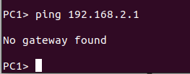

Couldn’t ping pc2 from pc1, as the are on different networks 192.168.x
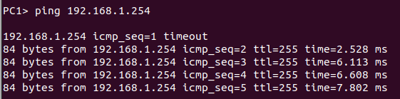

ping from pc1 to fe0/0, worked because same network
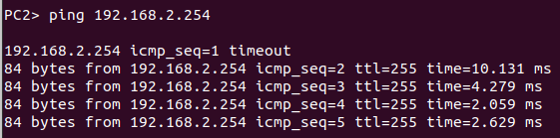

ping from pc2 to fe0/1, worked because same networks
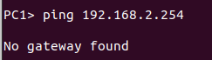

ping from pc1 to fe0/1, DOESN’T work because it is pinging a host address on a seperate network 192.168.x (1 =/= 2)
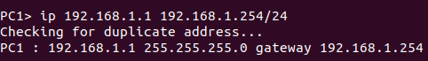

_{Gateway set on pc1}


Pinging pc2 from pc1 doesn’t work despite the gateway because there is no other gateway to connect to
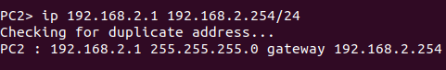

I created a second gateway on pc2
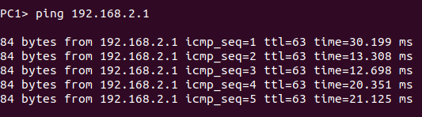

_{It now works as intended}

